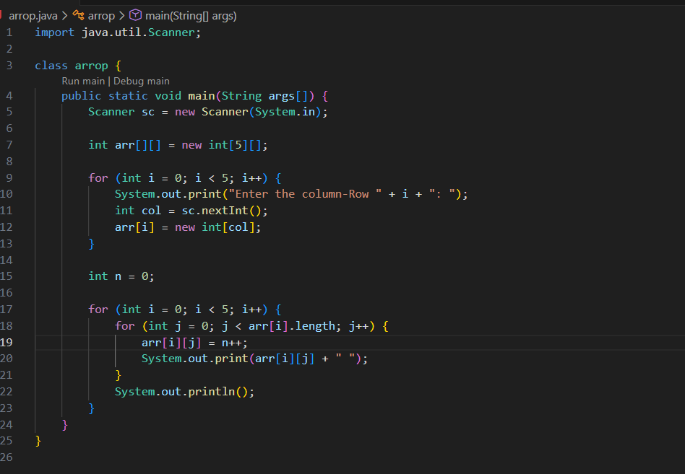
Output
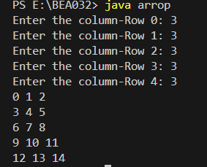

JAGGED ARRY

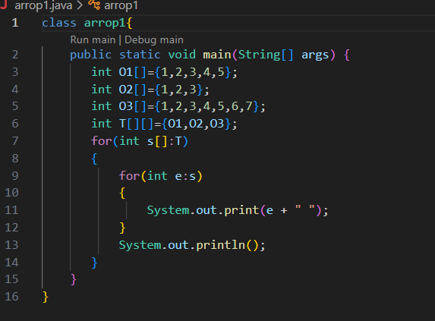
Output
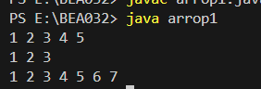

OOPs with ARRAY
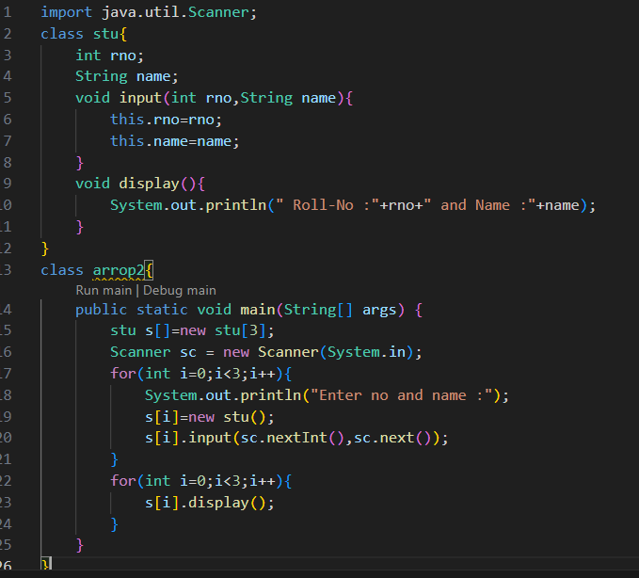
OutPut
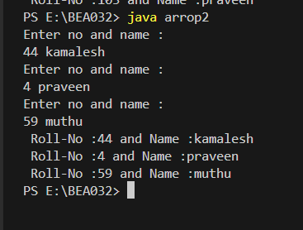

TCS CODE VITA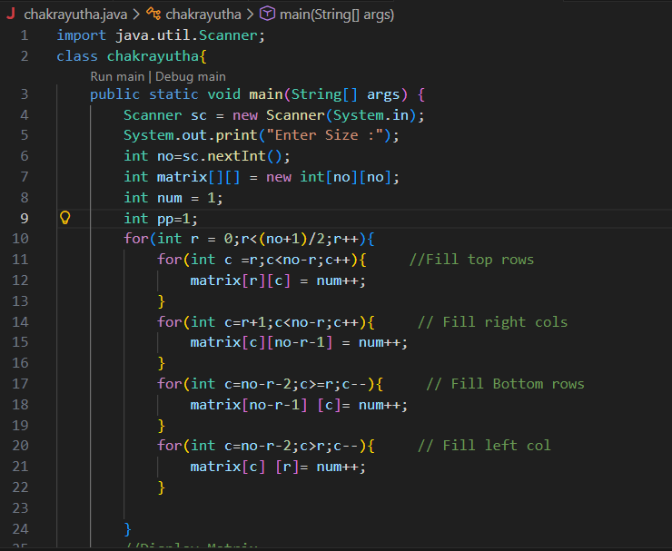
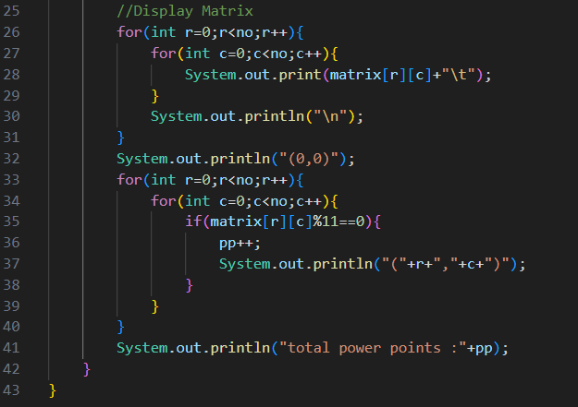

oUTpUT
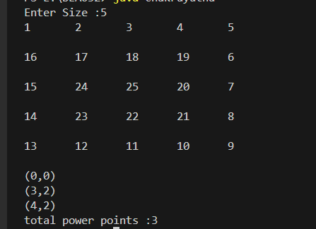
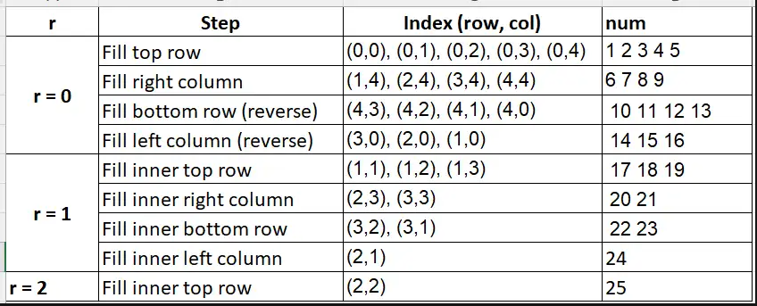
FOR LEETDODE PROBLEM NO : 59
class Solution {
public int[][] generateMatrix(int n) {

int matrix[][] = new int[n][n];
int num = 1;

for (int r = 0; r < (n + 1) / 2; r++) {

// Fill top row
for (int c = r; c < n - r; c++) {
matrix[r][c] = num++;
}

// Fill right column
for (int c = r + 1; c < n - r; c++) {
matrix[c][n - r - 1] = num++;
}

// Fill bottom row
for (int c = n - r - 2; c >= r; c--) {
matrix[n - r - 1][c] = num++;
}

// Fill left column
for (int c = n - r - 2; c > r; c--) {
matrix[c][r] = num++;
}
}

return matrix;
}
}
